PLEASE VOTE!!! DCBOE Begins Mailing Ballots; Mail Ballot Drop Boxes Open Oct. 14; Early Voting Oct. 31-Nov.6; Election Day is Tues. Nov. 8th.
Dear Neighbors,
My name is Roberta Shapiro. I hope to represent you, beginning January 2023, as ANC commissioner in the (new) 6A03 district. After 8 years of devoted service, Phil Toomajian is retiring as our commissioner and has endorsed me as candidate for 6A03.(Note: Due to the 2020 census, ANC districts have been redrawn as detailed in this link.)
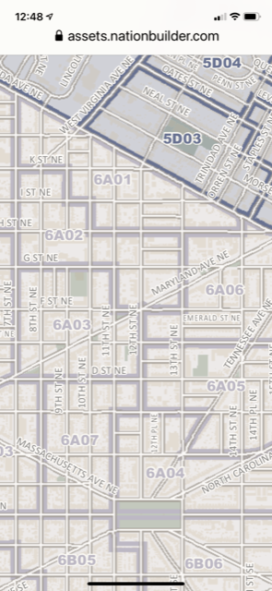
https://planning.dc.gov/sites/default/files/dc/sites/op/page_content/attachments/2023%20ANCs%20and%20SMDs%20Map.pdf
Advisory Neighborhood Councils (ANC) provide avenues for grassroots participation in important decisions made by city agencies on issues such as -- zoning, economic development, education, health/social services, public safety, liquor licenses, housing, transportation, the environment, and more. An ANC Commissioner also can act as a constituent services liaison to government agencies, especially in collaboration with city council members and their staffs.
Endorsed by Retiring Commissioner
Phil Toomajian

I would like to share a bit about me and the issues that I care about.
I am a retired from a career as a health care and not-for-profit manager and consultant. I’ve been vice-president of a not-for-profit teaching hospital, executive director of Ronald McDonald House Charities of Alabama, and of CommunityHealth, a Chicago-based free clinic. I’ve also held executive positions in several health insurance-related entities. I have a Masters in Public Health and also in a Masters in Business Administration.
Since my husband and I moved to DC in 2013, I’ve worked with not-for-profit entities, both as an employee and volunteer, including Capitol Hill Village, the Association of American Medical Colleges, Compass Pro Bono (a volunteer consultancy for non-profits), Good Neighbors Capitol Hill (refugee resettlement) and Washington English Center (as a volunteer ESL teacher.) I serve on our ANC’s Economic Development and Zoning (EDZ) Committee. I love the Hill, in part because it reminds me of the diverse and engaged Hyde Park community, in Chicago, where I grew up.
If elected ANC commissioner, some of my objectives would include:
- Communicating and listening to residents regarding key issues in our community, including public safety, transportation, health and social services, housing, environment and education.
- Encouraging development that supports diversity, equity, and the unique historic and residential nature of our community.
- Supporting timely and effective responses from DC government agencies and elected officials to residents’ concerns.
- Supporting grassroots efforts for DC statehood and protection of home rule.
I would be honored to have your support. If you have any questions about the elections, registering to vote, etc., go to: https://www.dcboe.org/Voters/Register-To-Vote/Register-to-Vote?ref=voteusa_en
Or, League of Women Voters: Personalized Ballot | VOTE411
If you would like to contact me directly, please email: robertafor6a03@yahoo.com.
Roberta

